Data Structure and Algorithm
Laboratory Activity No. 14

Tree Structure Analysis

Submitted by: | Instructor:
Monoy, Justin Rhey A. | Engr. Maria Rizette H. Sayo

November, 08, 2025

Objectives
Introduction
An abstract non-linear data type with a hierarchy-based structure is a tree. It is made up of links connecting nodes (where the data is kept). The root node of a tree data structure is where all other nodes and subtrees are connected to the root.

This laboratory activity aims to implement the principles and techniques in:
- To introduce Tree as Non-linear data structure
- To implement pre-order, in-order, and post-order of a binary tree
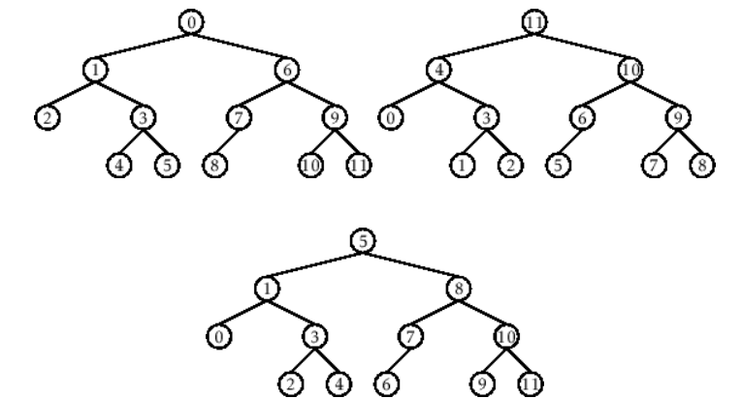

- Figure 1. Pre-order, In-order, and Post-order numberings of a binary tree

Methods
  - Copy and run the Python source codes.
  - If there is an algorithm error/s, debug the source codes.
  - Save these source codes to your GitHub.
  - Show the output

    - Tree Implementation

class TreeNode:
def __init__(self, value):
self.value = value
self.children = []

def add_child(self, child_node):
self.children.append(child_node)

def remove_child(self, child_node):
self.children = [child for child in self.children if child != child_node]

def traverse(self):
nodes = [self]
while nodes:
current_node = nodes.pop()
print(current_node.value)
nodes.extend(current_node.children)

def __str__(self, level=0):
ret = " " * level + str(self.value) + "\n"
for child in self.children:
ret += child.__str__(level + 1)
return ret

# Create a tree
root = TreeNode("Root")
child1 = TreeNode("Child 1")
child2 = TreeNode("Child 2")
grandchild1 = TreeNode("Grandchild 1")
grandchild2 = TreeNode("Grandchild 2")

root.add_child(child1)
root.add_child(child2)
child1.add_child(grandchild1)
child2.add_child(grandchild2)

print("Tree structure:")
print(root)

print("\nTraversal:")
root.traverse()

Questions:
- What is the main difference between a binary tree and a general tree?
- In a Binary Search Tree, where would you find the minimum value? Where would you find the maximum value?
- How does a complete binary tree differ from a full binary tree?
  - What tree traversal method would you use to delete a tree properly? Modify the source codes.

Results
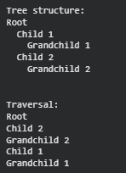
Figure 1: Tree Structure
1. Each node in a binary tree is limited to two children: a left child and a right child. It is useful for sorting and searching, similar to a binary search tree, because of this configuration. On the other hand, a general tree is more adaptable for things like file systems or organization charts because each node can have any number of offspring. Therefore, general trees are more adaptable to various types of data, whereas binary trees are more constrained but structured.

2. Every value on the left side of a node in a binary search tree (BST) is smaller, and every value on the right side is larger. Continue going to the left child until there are no more left nodes in order to discover the least value. Continue going to the right child until there are no more right nodes in order to find the greatest value.

3. All of the levels in a complete binary tree are filled, with the possible exception of the last level, which is filled fully from left to right. Every node in a full binary tree has either 0 or 2 children, never just one. This means that a complete tree focuses on how the tree is filled, while a full tree focuses on each node having two children. In other words, not all full trees are complete, and not all complete trees are full.

4. The best way to delete a tree is by using post-order traversal. This means you delete all child nodes first before deleting the parent node. In some programming languages, this helps prevent memory problems or “orphaned” nodes. Even in languages like Python, which handle memory automatically, using post-order still shows the correct order for clearing the tree.
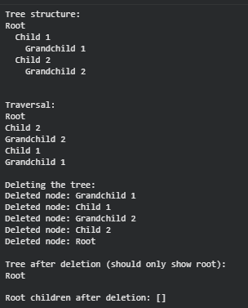

Conclusion
In conclusion, when deleting a tree, you should use post-order traversal, where all child nodes are deleted before the parent node. This prevents memory issues and makes sure no child nodes are left behind. By adding a delete_tree() method that removes the children first, the tree can be safely and completely deleted. This shows how important the order of traversal is when working with tree structures..

References
[1] GeeksforGeeks, “Difference between Full and Complete Binary Tree,” GeeksforGeeks, Jul. 23, 2025. https://www.geeksforgeeks.org/dsa/difference-between-full-and-complete-binary-tree/
[2] GeeksforGeeks, “Minimum in a binary search tree,” GeeksforGeeks, Oct. 11, 2025. https://www.geeksforgeeks.org/dsa/find-the-minimum-element-in-a-binary-search-tree/
[3] “W3Schools.com.” https://www.w3schools.com/dsa/dsa_data_binarysearchtrees.php

